International Cybersecurity and Digital Forensics Academy (ICDFA)
CIP-B103: Network Forensics Fundamentals
LAB 5: ARP Poisoning Forensics
Three-Week Delivery Block 2/3 | 25-26 July 2026
Prepared by: Aminu Idris, AMCPN | Founder, ICDFA
Important Pre-Lab Instruction
Read the matching lecture slide deck before executing the practical. Work only inside the ICDFA-approved lab or your own isolated virtual environment. Record every command, observation and screenshot as contemporaneous evidence.
Course Code | CIP-B103
Course Title | Network Forensics Fundamentals
Lab Number | Lab 5
Lab Title | ARP Poisoning Forensics
Students Name | Fuseini Imoru Kantuogaa
Student ID | 17291
Instructor Name | Dr. Sarah James
Delivery Block | 2/3 of 3
Scheduled Dates | 25-26 July 2026
Estimated Duration | 4-5 hours practical work plus report writing
Mode | Individual practical lab in an authorized virtual environment
Required Evidence | arp.pcap and an isolated host-only ARP capture

1. Source Materials and Slide Alignment
- Address Resolution Protocol Forensics: ARP operation, ARP caches, request/reply fields, capture with tshark, ARP spoofing/poisoning, man-in-the-middle consequences and evidence analysis.
- The slide practical compares clean and poisoned ARP tables and uses a supplied arp.py script only within the same LAN.
- The assignment requires legitimate ARP capture, spoofing capture and proof of a poisoned ARP table.
Reading Requirement Before Lab Execution
The lab deliberately follows the sequence, terminology and core exercises presented in the uploaded CIP-B103 slides. Commands have been corrected where needed for Linux syntax and forensic repeatability.

2. Lab Scenario
A user reports that the default gateway intermittently resolves to the wrong MAC address. You will first document normal ARP resolution, then analyze a known ARP-poisoning capture. In an instructor-approved host-only network, you may reproduce a short controlled poisoning event, capture the evidence, restore the ARP mappings and explain how the attack is detected.

3. Learning Outcomes
- Explain how ARP maps IPv4 addresses to MAC addresses on a LAN.
- Inspect ARP caches on Linux and Windows systems.
- Identify ARP requests, legitimate replies and unsolicited or conflicting replies.
- Detect one IP address being associated with multiple MAC addresses.
- Capture and document a bounded ARP-poisoning simulation in a host-only network.
- Restore network state and recommend preventive controls.

4. Legal, Ethical and Safety Rules
- Use only systems, packet captures and networks for which you have explicit authorization.
- Keep the lab isolated from production, campus, office and public networks. Use NAT or host-only virtual networking as instructed.
- Do not collect, disclose or reuse real credentials, personal messages or confidential traffic.
- Preserve original capture files. Perform analysis on verified working copies and record SHA-256 hashes.
- Stop any traffic-generation or interception process immediately after the required evidence is captured.
- Restore firewall, ARP, forwarding and network settings before closing the lab.
- The live component is optional and must use instructor-assigned RFC1918 addresses on a host-only/internal virtual switch. Never poison a home, school, office, hotel or public Wi-Fi network.

5. Required Tools and Environment
Item | Recommended Tool | Purpose
Virtual machines | Kali attacker/analyst plus Linux or Windows victim | Create an isolated LAN scenario.
Network mode | Host-only/internal network | Prevent access to production networks.
Capture tools | Wireshark and tshark | Capture ARP packets.
Packet library | python3-scapy | Run authorized training scripts.
System tools | ip neigh, arp, ipconfig /all | Inspect ARP tables and interfaces.
Evidence | arp.pcap or student capture | Analyze known poisoning indicators.

6. Lab Folder Structure and Evidence Preparation
mkdir -p ~/CIP-B103-Lab5/{evidence,working,exported,reports,screenshots,scripts}
cd ~/CIP-B103-Lab5
pwd
find . -maxdepth 1 -type d -print
Create the folder structure before downloading or generating evidence. Store original captures under evidence and analysis copies under working.
sudo apt update
sudo apt install -y wireshark tshark python3-scapy net-tools
wget -O evidence/arp.pcap \
'https://raw.githubusercontent.com/frankwxu/digital-forensics-lab/main/Networking_Forensics/lab_files/ARP_spoofing/arp.pcap'
cp --preserve=timestamps evidence/arp.pcap working/arp_working.pcap
sha256sum evidence/arp.pcap working/arp_working.pcap | tee reports/arp_capture_hashes.txt
ip -br address | tee reports/interfaces.txt
ip route | tee reports/routes.txt
ip neigh show | tee reports/arp_table_initial.txt
Screenshot required: Interface addresses, route/gateway, initial ARP table and evidence hashes.
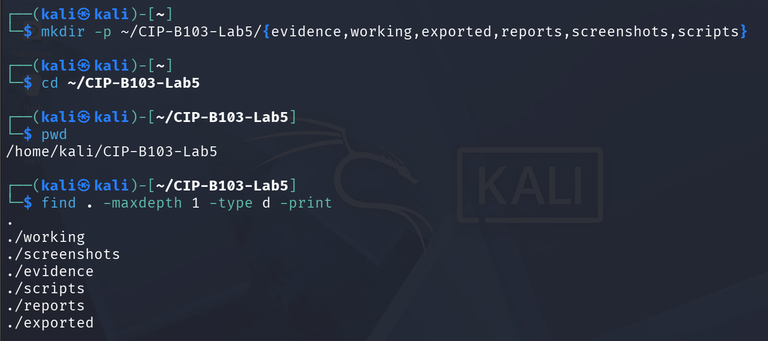
Screenshot 1: Evidence folder structure created (mkdir, cd, pwd, find).
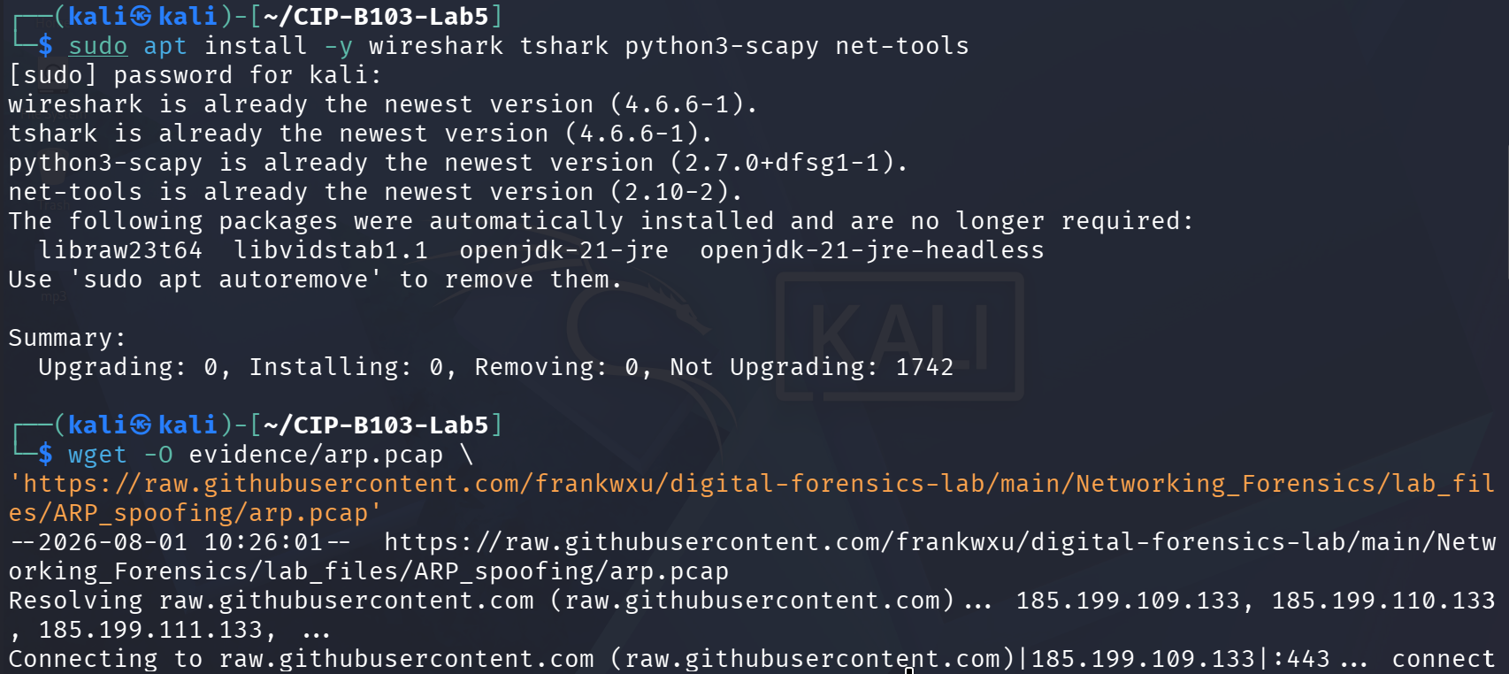
Screenshot 2: wireshark, tshark, python3-scapy, net-tools installed and arp.pcap downloaded.
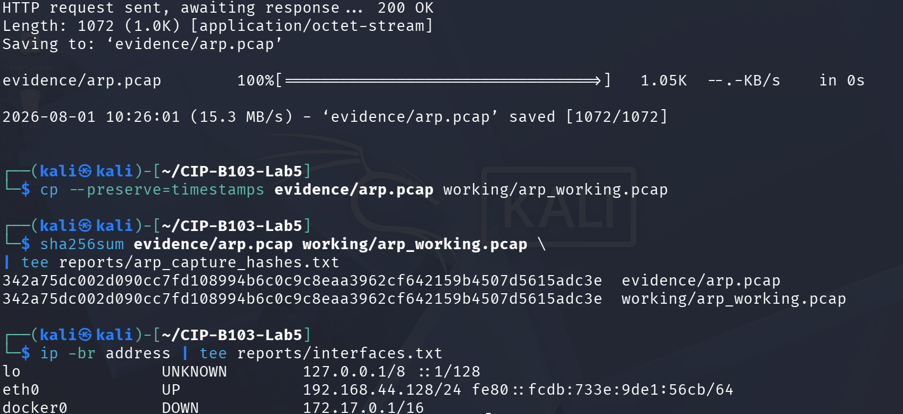
Screenshot 3: arp.pcap saved, hashed, and initial interface addresses listed.
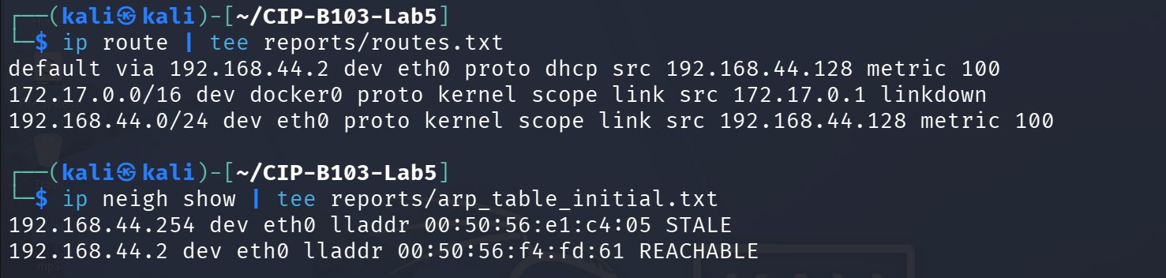
Screenshot 4: Route table and initial ARP (neighbor) table.
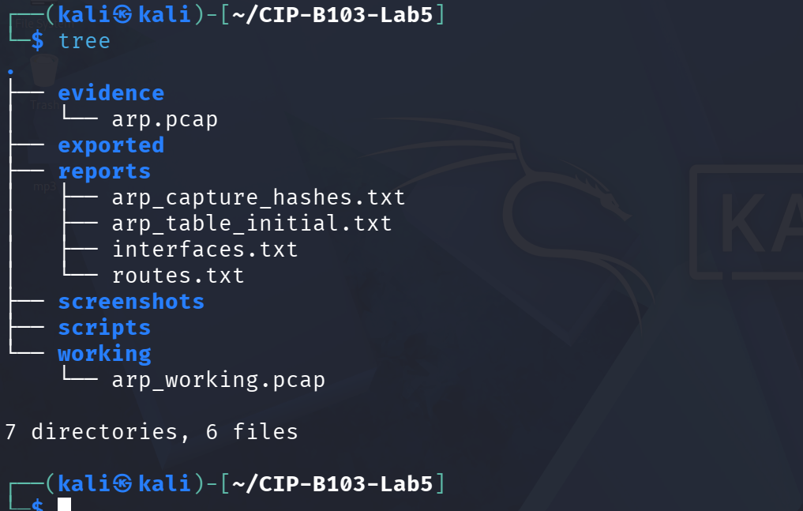
Screenshot 5: Evidence folder tree after Part preparation.

7. Mini Evidence and Chain-of-Custody Worksheet
Field | Student Entry
Case/lab identifier | CIP-B103-Lab5-Fuseini Imoru Kantuogaa
Trainee name | Fuseini Imoru Kantuogaa
Date and time started | 1 August 2026, approx. 10:26 local (Kali VM) — timestamp of the wget download of the evidence file
Evidence file name(s) | arp.pcap (working copy: arp_working.pcap); locally generated evidence/normal_arp.pcapng (Part A); evidence/controlled_arp_poison.pcapng attempted but incomplete (Part D, see notes)
Source or generation method | arp.pcap downloaded via wget from the frankwxu digital-forensics-lab GitHub repository (a historical supplied ARP-spoofing sample, internally timestamped 11 Mar 2023); normal_arp.pcapng captured locally with tshark on eth0 while pinging the default gateway
Original SHA-256 | 342a75dc002d090cc7fd108994b6c0c9c8eaa3962cf642159b4507d5615adc3e (evidence/arp.pcap)
Working-copy SHA-256 | 342a75dc002d090cc7fd108994b6c0c9c8eaa3962cf642159b4507d5615adc3e (working/arp_working.pcap) — identical to original
Analysis workstation/VM | Kali Linux (user: kali), CIP-B103-Lab5 working directory, host-only interface eth0 (192.168.44.128/24, gateway 192.168.44.2)
Notes on any changes | cp --preserve=timestamps used for the working copy; SHA-256 matched exactly. The optional Part D controlled simulation hit a permission error writing directly to evidence/ and was redirected to /tmp; the screenshots do not show scripts/arp.py actually being run or a resulting changed ARP mapping before the trainee moved on to the restoration commands — Part D should be treated as attempted but inconclusive.

8. Part A - Observe Normal ARP Resolution
- Identify the victim IP, gateway IP and your interface name.
- Clear only the specific training neighbor entry where permitted.
- Start an ARP-only capture, ping the gateway once and stop the capture.
- Identify the broadcast request and unicast reply.
IFACE=eth0
GATEWAY_IP=$(ip route | awk '/default/ {print $3; exit}')
sudo ip neigh flush "$GATEWAY_IP" dev "$IFACE"
sudo tshark -i "$IFACE" -f 'arp' -a duration:20 -w evidence/normal_arp.pcapng &
sleep 2
ping -c 1 "$GATEWAY_IP"
wait
ip neigh show | tee reports/arp_table_after_ping.txt
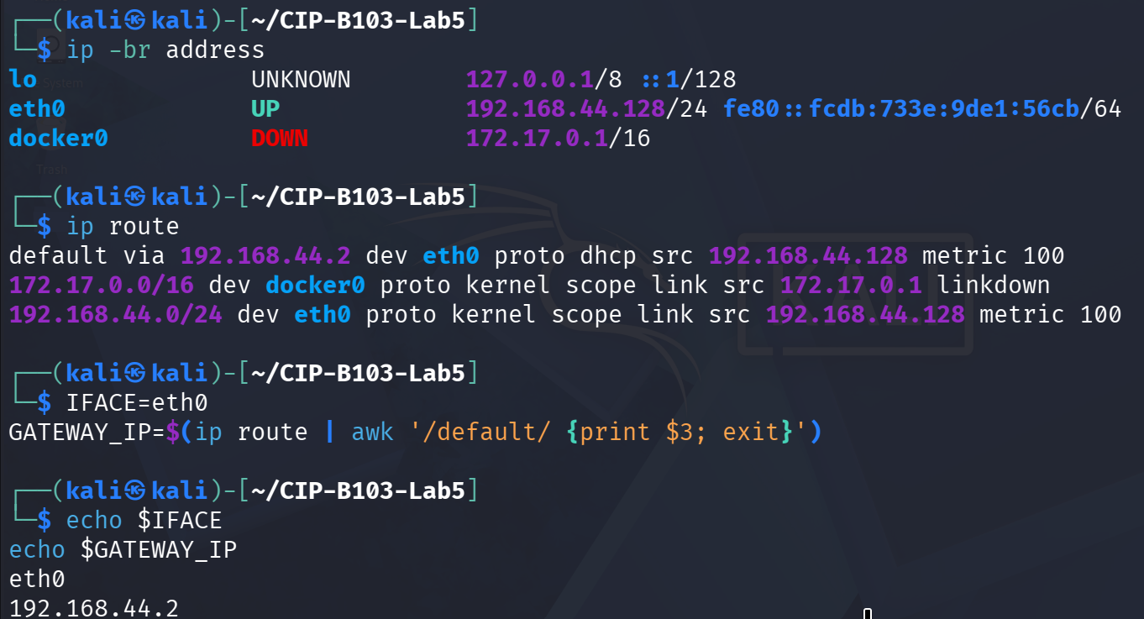
Screenshot 6: Interface/route recheck, IFACE and GATEWAY_IP variables set.
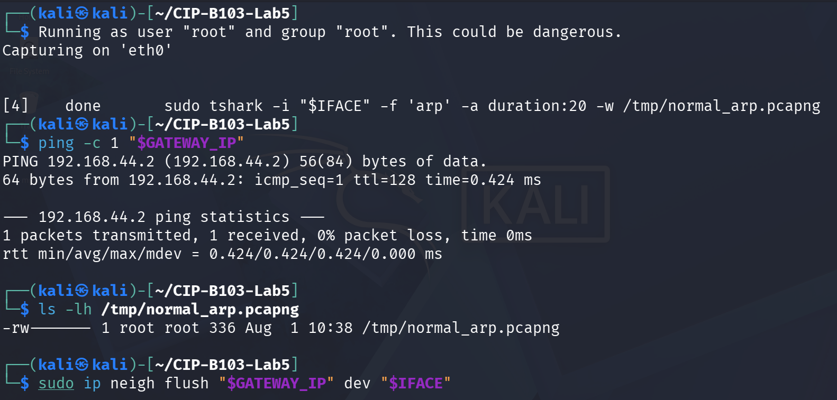
Screenshot 7: Normal ARP capture started, gateway pinged, and ARP entry flushed beforehand.
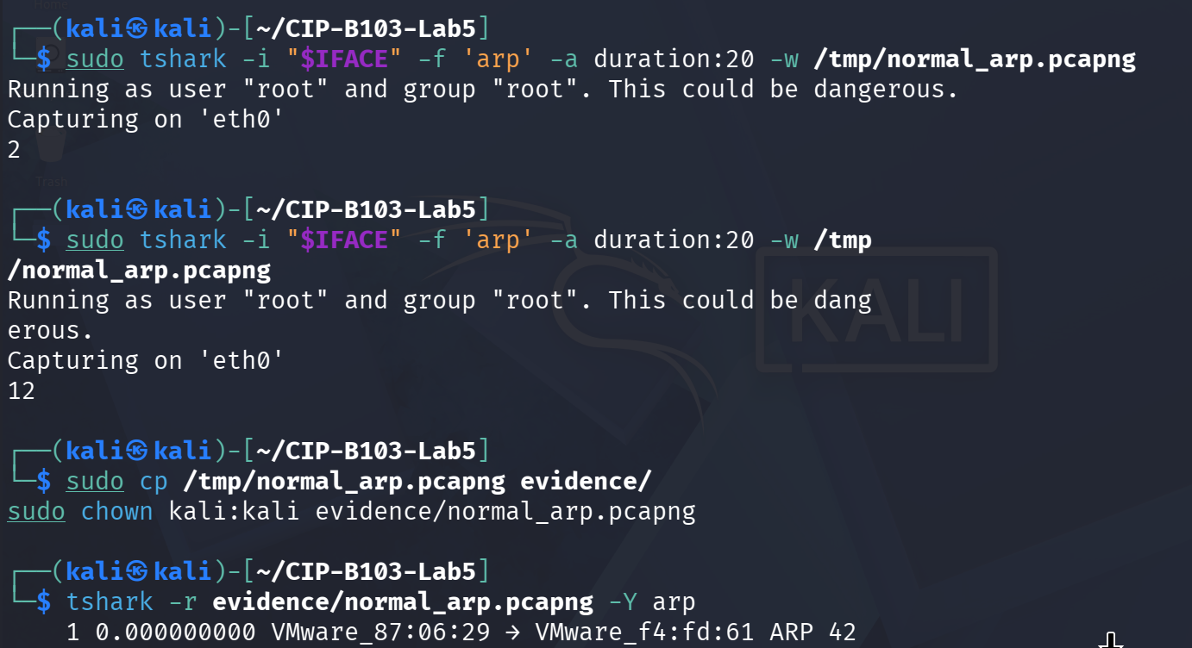
Screenshot 8: Capture copied to evidence/ and tshark -Y arp showing the broadcast request and reply (plus background traffic).
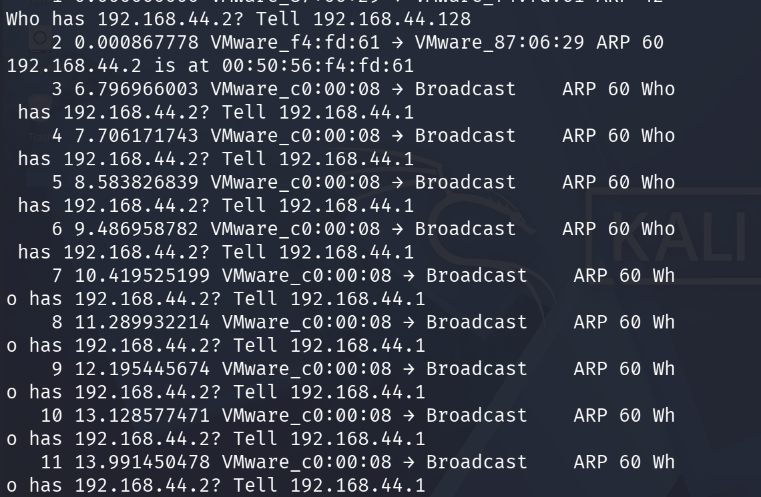
Screenshot 9: Continued arp listing — repeated broadcast requests from a second host for the gateway IP.

9. Part B - Analyze ARP Request and Reply Fields
tshark -r evidence/normal_arp.pcapng -Y 'arp' -T fields \
-e frame.number -e frame.time -e eth.src -e eth.dst -e arp.opcode \
-e arp.src.proto_ipv4 -e arp.src.hw_mac -e arp.dst.proto_ipv4 -e arp.dst.hw_mac \
| tee reports/normal_arp_fields.tsv
Field | Normal Request | Normal Reply
Ethernet destination | ff:ff:ff:ff:ff:ff | Requester MAC
ARP opcode | 1 | 2
Sender protocol address | Requester IP | Target IP
Sender hardware address | Requester MAC | Target MAC
Target protocol address | Target IP | Requester IP
Forensic interpretation | Who has target IP? | Target IP is at target MAC.  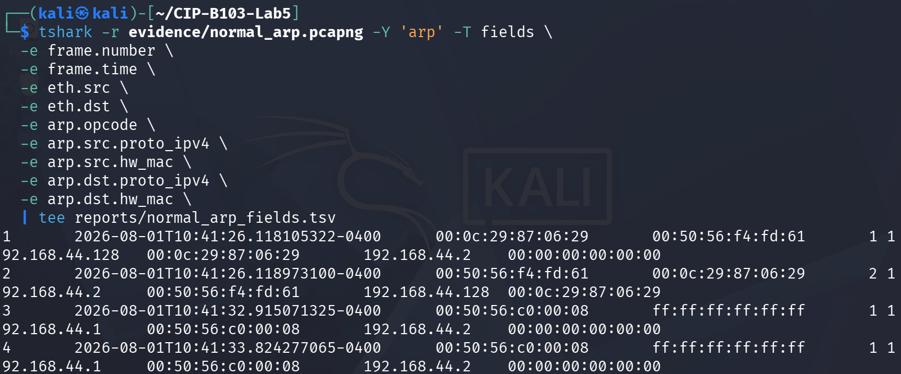  Screenshot 10: Field extraction of the normal ARP capture (request and reply, start).  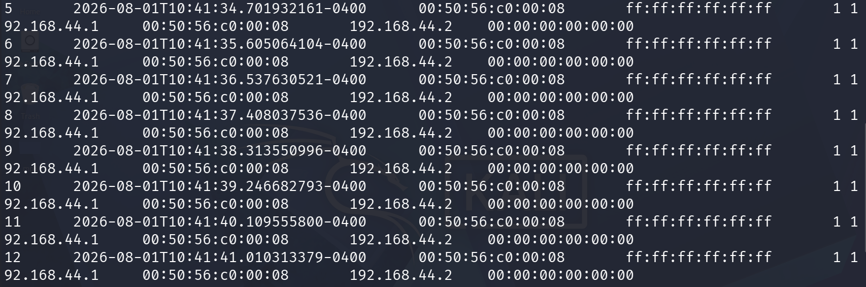  Screenshot 11: Field extraction continued — repeated background broadcast requests.  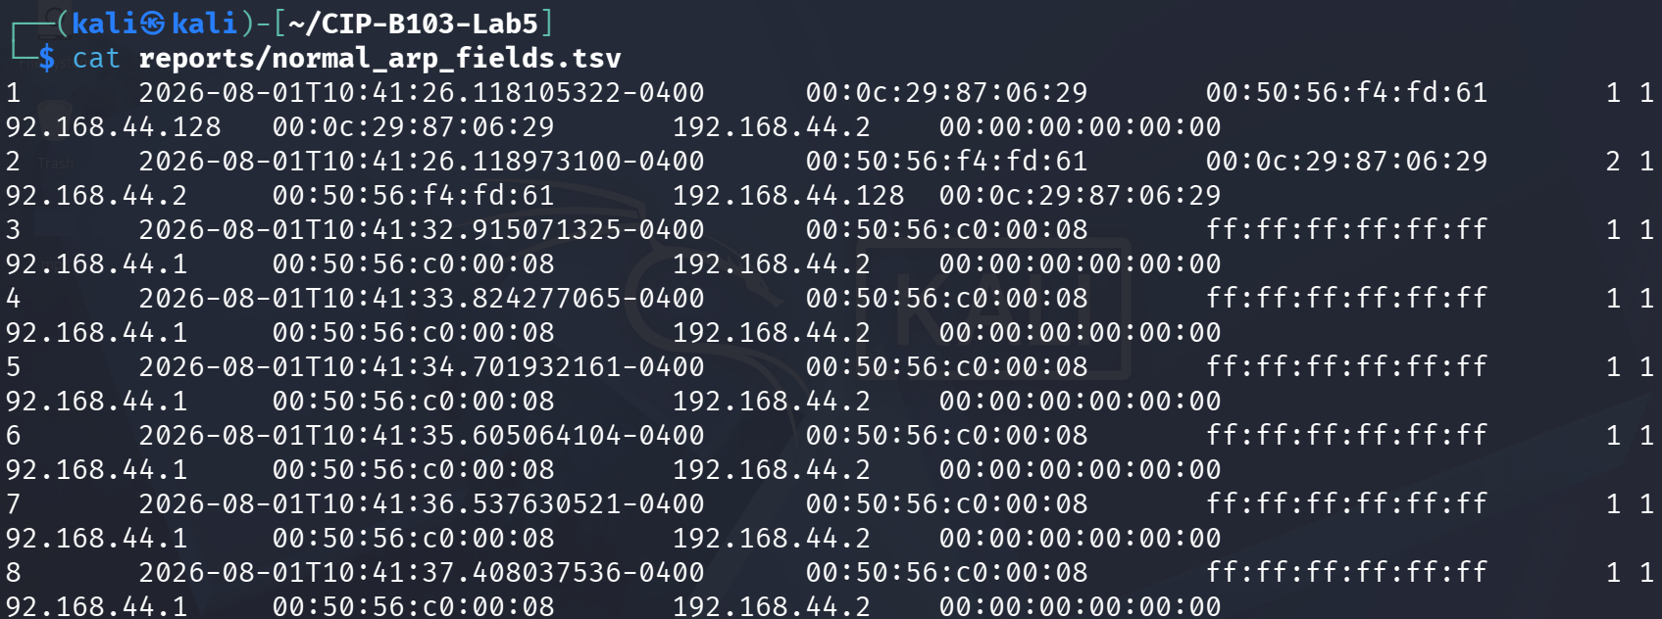  Screenshot 12: reports/normal_arp_fields.tsv contents confirmed via cat.

10. Part C - Analyze the Supplied Poisoning Capture
PCAP=working/arp_working.pcap
# Inventory all ARP claims
tshark -r "$PCAP" -Y 'arp.opcode==2' -T fields \
-e frame.number -e frame.time_epoch -e eth.src -e eth.dst \
-e arp.src.proto_ipv4 -e arp.src.hw_mac -e arp.dst.proto_ipv4 -e arp.dst.hw_mac \
| tee reports/arp_replies.tsv
# Summarize IP-to-MAC claims
tshark -r "$PCAP" -Y 'arp.opcode==2' -T fields -e arp.src.proto_ipv4 -e arp.src.hw_mac \
| sort | uniq -c | sort -nr | tee reports/ip_mac_claims.txt
# Look for gratuitous or unsolicited-looking replies
tshark -r "$PCAP" -Y 'arp.opcode==2 && eth.dst!=ff:ff:ff:ff:ff:ff' -T fields \
-e frame.number -e frame.time -e arp.src.proto_ipv4 -e arp.src.hw_mac -e eth.dst \
| tee reports/unicast_arp_replies.tsv
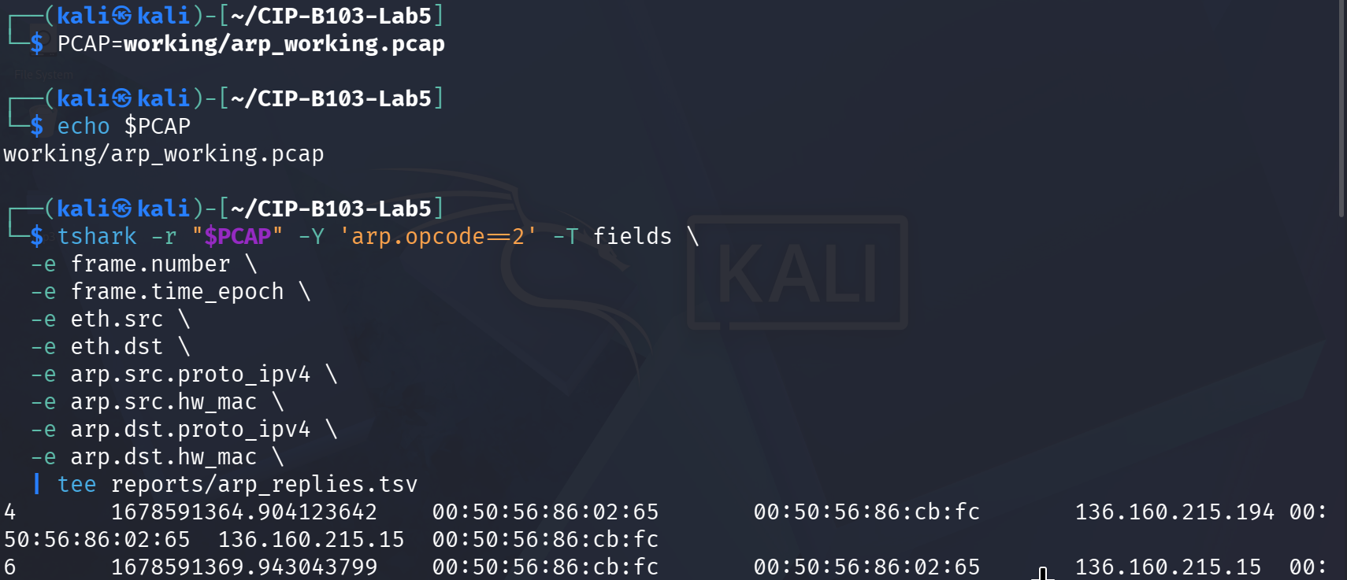
Screenshot 13: Supplied arp.pcap analyzed — ARP reply inventory (arp.opcode==2).
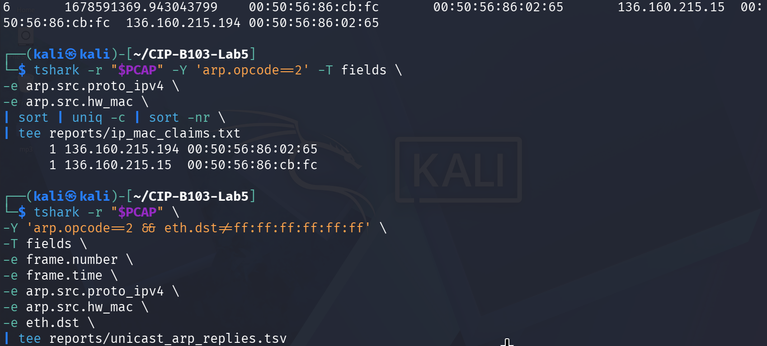
Screenshot 14: IP-to-MAC claim summary and start of the unicast-reply filter.
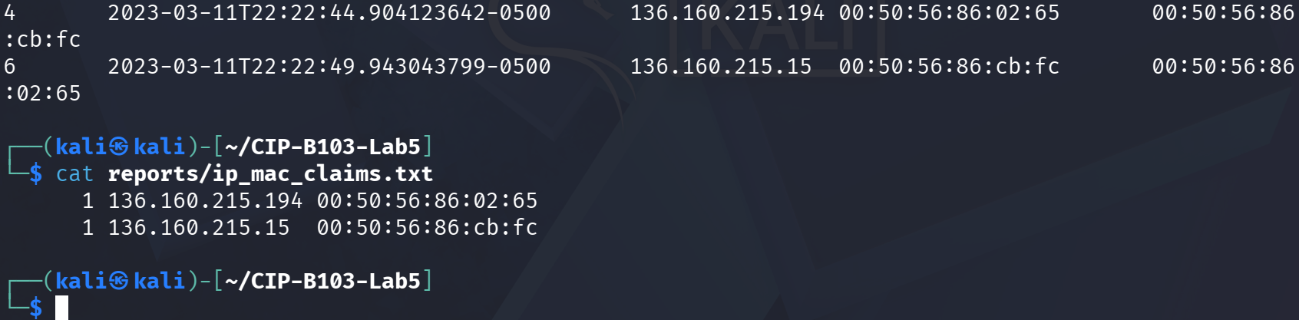
Screenshot 15: Unicast ARP replies confirmed and ip_mac_claims.txt contents.

11. Part D - Optional Controlled Host-Only Simulation
Instructor Approval Required
Skip this section unless the virtual network is confirmed as host-only/internal and the victim, gateway and analyst IP addresses are assigned specifically for the lab.
- Record clean ARP tables on victim and gateway.
- Start ARP capture on the analyst VM.
- Run the instructor-provided arp.py for no more than 30 seconds.
- Capture the changed victim mapping and stop the script.
- Restore correct ARP mappings or restart the isolated VMs.
# Example placeholders only - replace with instructor-assigned lab IPs
VICTIM_IP=192.168.56.20
GATEWAY_IP=192.168.56.1
IFACE=eth0
sudo tshark -i "$IFACE" -f 'arp' -a duration:40 -w evidence/controlled_arp_poison.pcapng &
sleep 2
# In another terminal, run the instructor-provided script for <=30 seconds:
# sudo timeout 30 python3 scripts/arp.py "$VICTIM_IP" "$GATEWAY_IP"
wait
ip neigh show | tee reports/analyst_arp_table_after.txt
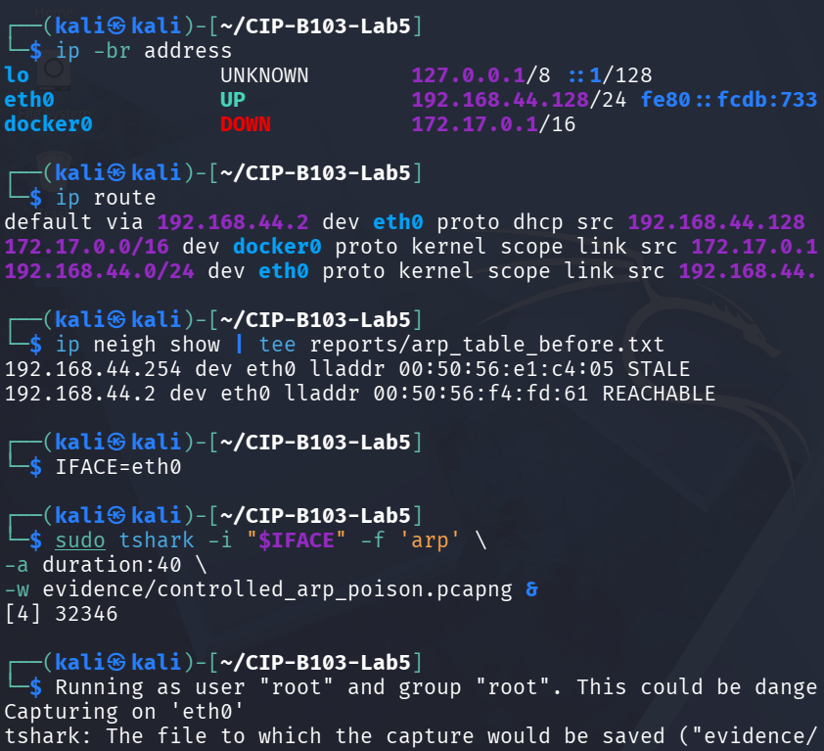
Screenshot 16: Pre-simulation ARP table recorded; controlled capture attempted (initial permission error writing to evidence/).
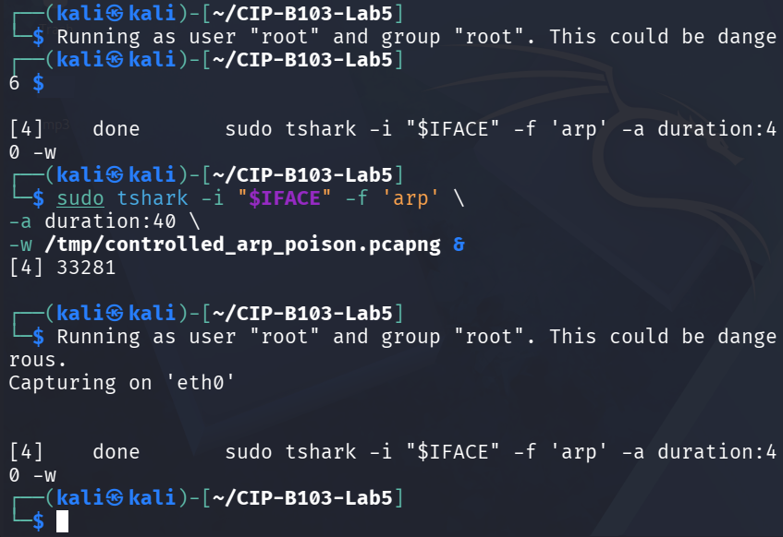
Screenshot 17: Controlled capture retried, writing to /tmp/controlled_arp_poison.pcapng.

12. Part E - Detection Logic and Timeline
Time | Claimed IP | Claimed MAC | Target | Request Seen First? | Assessment
2023-03-11 22:22:44.904 -0500 (frame 4) | 136.160.215.194 | 00:50:56:86:02:65 | 136.160.215.15 (unicast reply, eth.dst = 00:50:56:86:cb:fc) | No corresponding request visible in this short excerpt | Unsolicited/gratuitous-style unicast reply; only one MAC claimed this IP in the sample — no second conflicting claim was captured, so this alone is suggestive but not conclusive proof of poisoning.
2023-03-11 22:22:49.943 -0500 (frame 6), ~5.04 s later | 136.160.215.15 | 00:50:56:86:cb:fc | 136.160.215.194 (unicast reply, eth.dst = 00:50:56:86:02:65) | No corresponding request visible in this short excerpt | Reciprocal unsolicited unicast reply from the other host; the two replies together form a classic bidirectional ARP-spoofing pattern (each host told the other party's MAC directly), though again no dual-MAC conflict is present in this 8-frame sample.
Summary across evidence/arp.pcap | Only 2 distinct IP-to-MAC claims total (1 each) | n/a | n/a | n/a | reports/ip_mac_claims.txt shows exactly one claim per IP — this short supplied capture illustrates the unicast-reply technique used in ARP spoofing but does not itself contain a repeated/conflicting claim; a fuller capture would be needed to confirm an active poisoning campaign.
Part D (controlled simulation) | Not captured | Not captured | Not captured | n/a | The optional host-only simulation was started but scripts/arp.py does not appear to have been executed in the supplied screenshots, and reports/analyst_arp_table_after.txt was not produced — no live poisoning evidence is available from Part D in this submission.
- Flag a gateway IP that changes from its legitimate MAC to the analyst/attacker MAC.
- Flag repeated ARP replies without a corresponding recent request.
- Flag one MAC claiming both victim and gateway IP addresses.
- Correlate ARP evidence with packet forwarding, DNS/HTTP anomalies and endpoint ARP-cache changes.

13. Restoration and Prevention
# Stop any training script first, then clear learned entries on the lab VM
sudo ip neigh flush all
# Renew/reconnect the isolated interface as appropriate
ip neigh show
# Confirm no ARP-poisoning process remains
ps aux | grep -E '[a]rp.py|[s]capy' | tee reports/process_check.txt
- Use Dynamic ARP Inspection with DHCP snooping on managed switches where available.
- Segment networks, enable port security and monitor gateway IP-to-MAC consistency.
- Use encrypted application protocols so interception does not expose plaintext.
- Deploy ARP monitoring tools and correlate alerts with switch and endpoint logs.
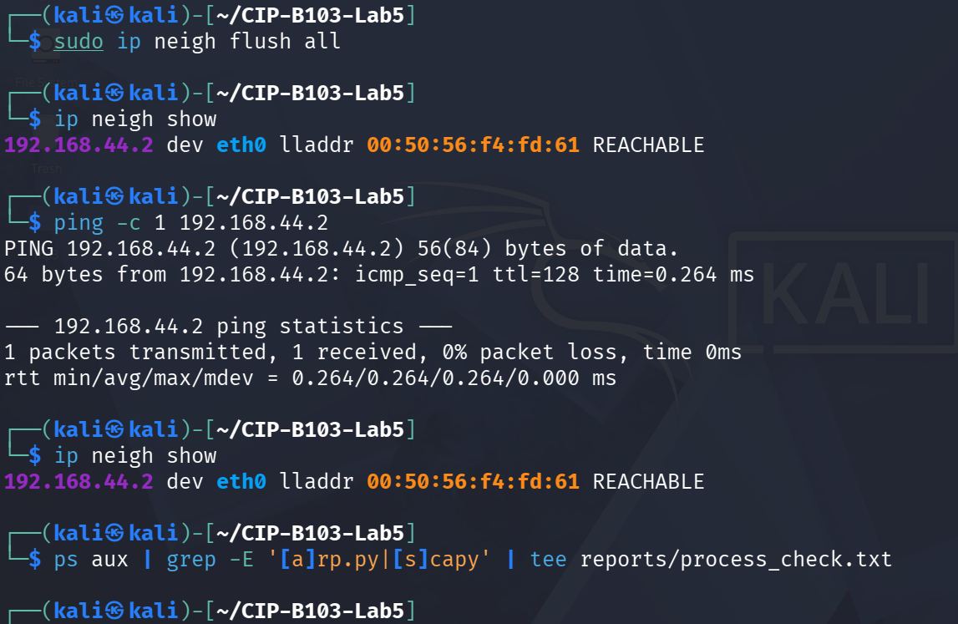
Screenshot 18: Restoration — ip neigh flush all, ARP table re-verified, gateway re-pinged, and no arp.py/scapy process remaining.

Required Screenshots Checklist
☐ Initial interface, route and ARP table.
☐ Normal broadcast ARP request.
☐ Normal ARP reply.
☐ Supplied capture hash.
☐ ARP reply inventory.
☐ IP-to-MAC claim summary.
☐ Conflicting gateway MAC evidence.
☐ Clean versus poisoned ARP table comparison.
☐ Controlled capture, if authorized.
☐ Restored ARP table and process check.

Student Report Template
- Executive summary and authorization.
- Network diagram and assigned IP/MAC addresses.
- Evidence integrity.
- Normal ARP behaviour.
- Poisoning indicators and timeline.
- ARP-table comparison.
- Impact assessment.
- Restoration and preventive controls.
- Appendix.

Submission Requirements
- One PDF report named CIP-B103-Lab5_RegNo_FullName.pdf.
- The original or generated PCAP/PCAPNG evidence file and its SHA-256 hash text file.
- A reports folder containing exported CSV/TXT command output and any recovered objects.
- Screenshots must be readable, numbered and referenced in the report narrative.
- Compress the report and evidence outputs into one ZIP named with your registration number and lab number.
- Do not submit passwords or decoded credentials in public discussion channels; include them only in the protected assessment submission where required.

Marking Rubric (100 Marks)
Assessment Area | Marks | What the Instructor Will Check
Safety and environment | 15 | Host-only scope and restoration documented.
Normal ARP analysis | 15 | Request/reply fields and ARP-cache behaviour.
Poisoning detection | 25 | Conflicting claims, unsolicited replies and timeline.
Controlled evidence or supplied PCAP analysis | 20 | Complete, repeatable capture analysis.
Mitigation and restoration | 15 | Correct cleanup and preventive controls.
Report quality | 10 | Clear diagram, screenshots and conclusions.

Instructor Quick Answer Guide
Checkpoint | Expected Observation
ARP request opcode | 1.
ARP reply opcode | 2.
Broadcast destination | ff:ff:ff:ff:ff:ff for a typical request.
Poisoning indicator | An IP, especially the gateway, is claimed by a different MAC.
Unsolicited reply | ARP reply appears without a corresponding request.
MITM pattern | Attacker MAC is inserted for victim and/or gateway IP mappings.

Command Reference Summary
Command | Purpose
ip neigh show | Display Linux neighbor/ARP cache.
arp -a | Display legacy ARP table.
arp.opcode==1 | Filter ARP requests.
arp.opcode==2 | Filter ARP replies.
arp.src.proto_ipv4 | Claimed sender IP.
arp.src.hw_mac | Claimed sender MAC.

Academic Integrity and Authorization Statement
Student Declaration
I confirm that I completed this lab in an authorized environment, preserved the supplied evidence, did not target any third-party system, and accurately documented my own commands, observations and conclusions.

